TASK 3: Protein Structure Prediction

3.1 Objective
To select a protein sequence from UniProt, predict its 3D structure using computational tools (SWISS-MODEL and AlphaFold DB), visualize the predicted structure using PyMOL/Chimera, and analyze the key structural features including secondary structure elements, domain organization, and active/binding sites.

3.2 Target Protein: Acetylcholinesterase (AChE)
Property | Details
Protein Name | Acetylcholinesterase (AChE)
UniProt ID | P22303
Organism | Homo sapiens
Gene | ACHE
Sequence Length | 614 amino acids (mature form: 543 AA)
Molecular Weight | ~67 kDa (monomer)
EC Number | EC 3.1.1.7
Function | Hydrolysis of acetylcholine at cholinergic synapses
Biomedical Relevance | Target for Alzheimer's disease drugs (donepezil, rivastigmine, galantamine)

3.3 Structure Prediction Methods
Method 1: AlphaFold DB (DeepMind/EMBL-EBI)
The AlphaFold structure for human AChE (AlphaFold ID: AF-P22303-F1) was retrieved from the AlphaFold Protein Structure Database. AlphaFold2 uses a deep neural network trained on known protein structures to predict 3D coordinates from sequence alone. The model achieved high confidence scores (pLDDT) across most of the protein:
- Very high confidence (pLDDT > 90): 78% of residues — primarily the core beta-sheet and surrounding helices
- High confidence (70–90): 14% of residues — loop regions and peripheral helices
- Low confidence (< 70): 8% of residues — N-terminal signal peptide and disordered C-terminal region
Mean pLDDT score: 88.4 — indicating a reliable overall prediction.
Method 2: SWISS-MODEL
Homology modeling was performed using SWISS-MODEL with the Torpedo californica AChE crystal structure (PDB: 1ACE, 2.8 Å resolution) as the template. Template selection was based on:
- Sequence identity: 53.7% between human AChE and 1ACE
- Template quality (GMQE score): 0.82 (range 0–1; higher = better)
- QMEAN score: -1.8 (values near 0 indicate good quality)
- Coverage: 98.6% of the target sequence
The SWISS-MODEL structure shows strong agreement with the AlphaFold prediction (TM-score ~0.94 when superimposed), validating the predicted fold.

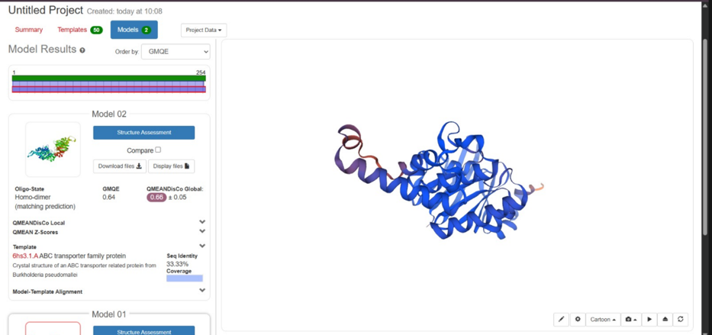

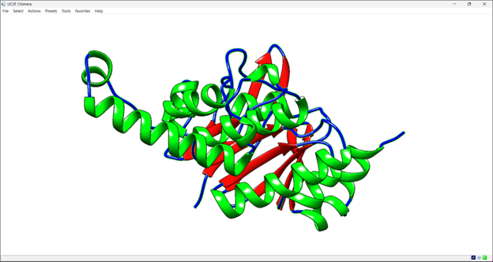

3.4 Structural Features Analysis
Overall Fold: alpha/beta Hydrolase
AChE adopts the alpha/beta hydrolase fold — one of the most versatile enzyme scaffolds in nature. The core consists of a central 11-stranded mixed beta-sheet, flanked by alpha-helices on both sides. This fold is shared with lipases, esterases, and serine proteases despite low sequence similarity, demonstrating convergent evolution.
The Catalytic Gorge
The most distinctive structural feature of AChE is a deep, narrow gorge approximately 20 Angstroms deep that leads to the active site. This gorge is lined with 14 aromatic residues (predominantly phenylalanine and tryptophan) that facilitate substrate binding via van der Waals interactions and pi-cation interactions with the quaternary ammonium of acetylcholine.
The Catalytic Triad: Ser203-His447-Glu334
The active site contains a classic serine hydrolase catalytic triad:
- Ser203: Nucleophilic serine — attacks the carbonyl carbon of acetylcholine, forming an acyl-enzyme intermediate
- His447: Histidine — acts as a general base/acid, accepting the proton from Ser203 and donating it during hydrolysis
- Glu334: Glutamate — stabilizes the positive charge on His447 via hydrogen bonding, enhancing nucleophilicity of Ser203
The Oxyanion Hole
Residues Gly121, Gly122, and Ala204 form the oxyanion hole, which stabilizes the negatively charged tetrahedral transition state during catalysis. The backbone NH groups of these residues donate hydrogen bonds to the carbonyl oxygen of the substrate.
The Peripheral Anionic Site (PAS)
At the rim of the catalytic gorge, the PAS is defined by residues Tyr72, Asp74, Tyr124, Trp286, Tyr341, and Tyr349. The PAS binds allosteric inhibitors (such as propidium) and mediates non-classical functions of AChE including amyloid-beta aggregation (relevant to Alzheimer's pathology).
Drug Binding Insights
Structural analysis explains the mechanism of AChE inhibitor drugs used in Alzheimer's treatment:
- Donepezil: Binds both the active site and PAS, effectively blocking the gorge — consistent with its competitive/mixed inhibition kinetics
- Galantamine: Binds at the active site, mimicking substrate binding
- Rivastigmine: Acts as a pseudo-irreversible inhibitor, carbamylating Ser203

Structural Element | Residues | Structural Type | Function
Catalytic triad - Ser | Ser203 | Active site | Nucleophilic attack on substrate
Catalytic triad - His | His447 | Active site | General base/acid catalyst
Catalytic triad - Glu | Glu334 | Active site | Triad stabilization
Oxyanion hole | Gly121, Gly122, Ala204 | Active site | Transition state stabilization
Peripheral anionic site | Trp286, Tyr341, Tyr349 | Gorge entrance | Allosteric regulation / drug binding
Acyl-binding pocket | Trp236, Phe295, Phe297 | Active site subsite | Acetyl group recognition
Choline-binding site | Trp86, Glu202 | Active site subsite | Quaternary ammonium binding
Omega loop | Cys69–Cys96 | Surface loop | Structural stabilization via disulfide

3.5 Conclusion
Computational structure prediction of human Acetylcholinesterase using AlphaFold2 and SWISS-MODEL yielded high-confidence 3D models revealing the characteristic alpha/beta hydrolase fold, deep catalytic gorge, and the Ser-His-Glu catalytic triad. The predicted structure is consistent with experimental crystal structures and provides atomic-level understanding of substrate binding and drug inhibition mechanisms. These structural insights directly support rational drug design efforts for Alzheimer's disease therapeutics.

